NOW TAKING CHRISTMAS ORDERS FOR WALT’S FRIED TURKEYS 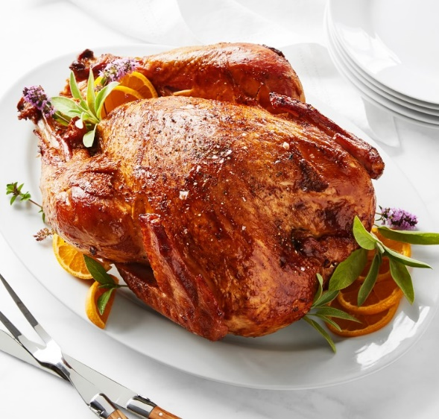
$64.95 $99.95 FOR A MEAL- INCULDES 5 LG SIDES AND 12 ROLLS
LAST DAY TO ORDER IS DEC. 18-2021(or until we reach our capacity)

